Seventh Annual
Marilou & Don Jolly Memorial
Sacred Harp Singing
A traditional gathering of FaSoLa singers
Saturday, July 26, 2003

Grand Room of the Porter House in Old Poway Park
14134 Midland Road, Poway, California

Registration at 9:00 am, Singing 10:00 am to 4:00 pm

Potluck Dinner-on-the-Ground at 12:30 pm

Limited kitchen facilities – bring potluck contributions in your own ice chest

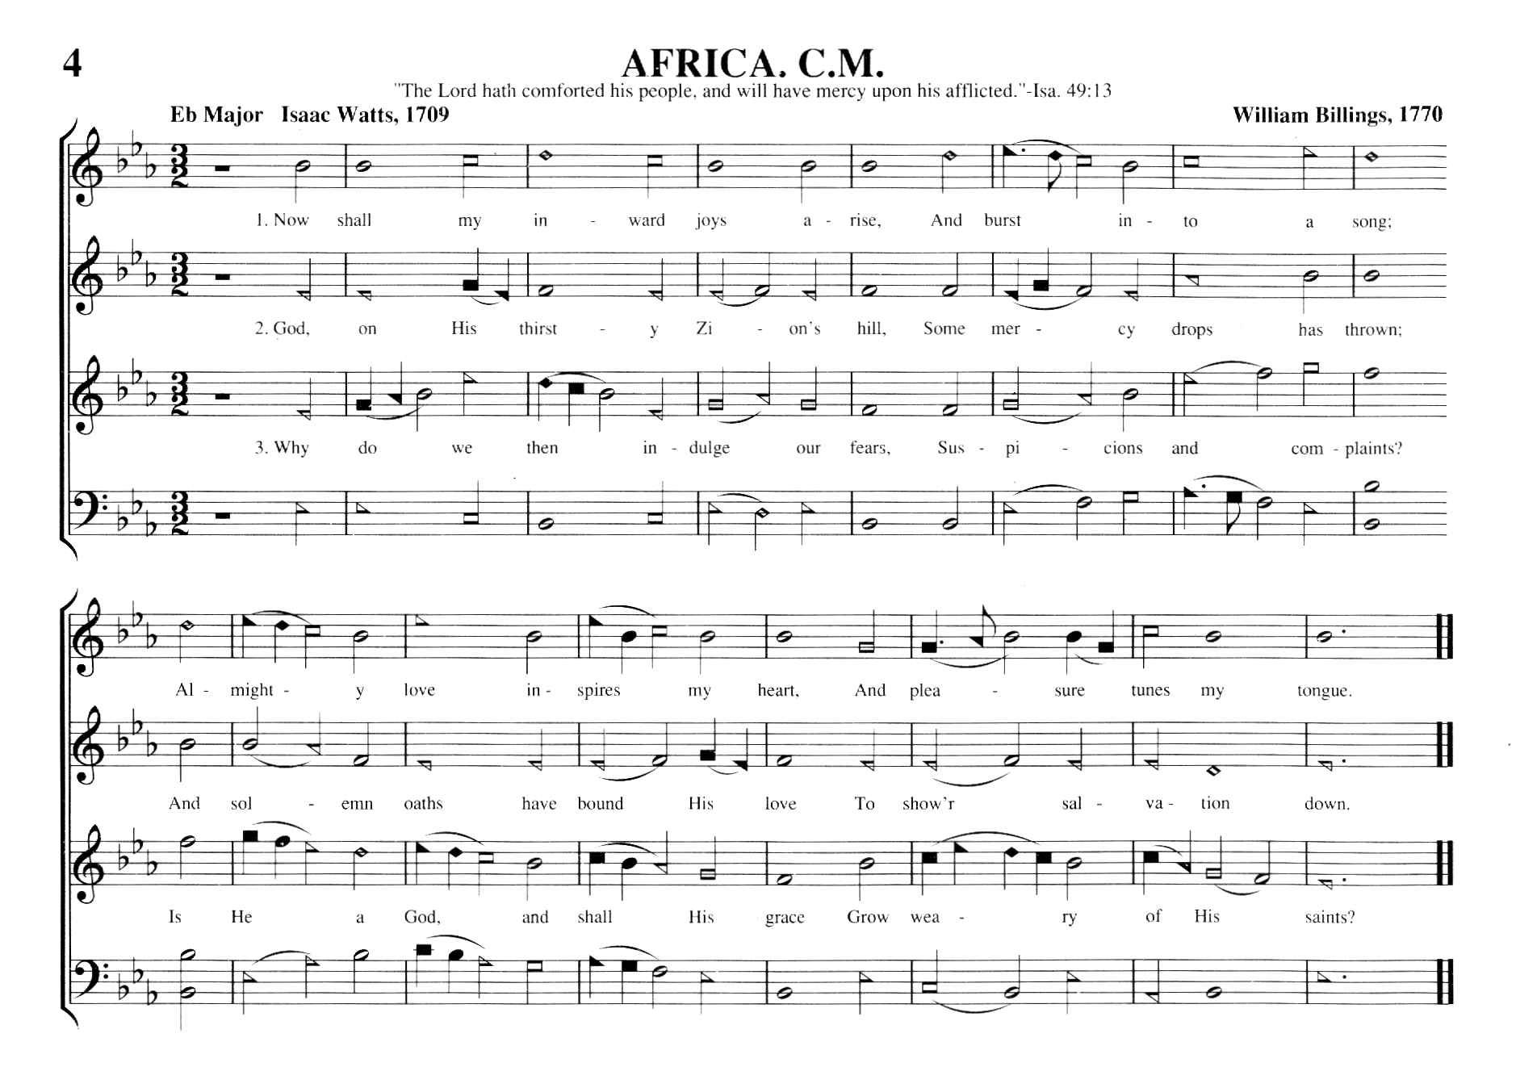
For information: (619) 544-0432 or DrXOX@aol.com

Directions:
From San Diego:I-15 north to Poway Rd. east. Turn left on Midland Rd. Old Poway Park is on left, north of Temple St.
From Riverside: I-15 south to Camino del Norte east. Street changes name to Twin Peaks Road. Turn right (south) on Midland Road Old Poway Park is on the right, south of Aubrey Street
From L.A.: I-5 south to SR78 east to I-15 south. Then follow above directions (from Riverside)

 | Sponsored by San Diego Folk Heritage

